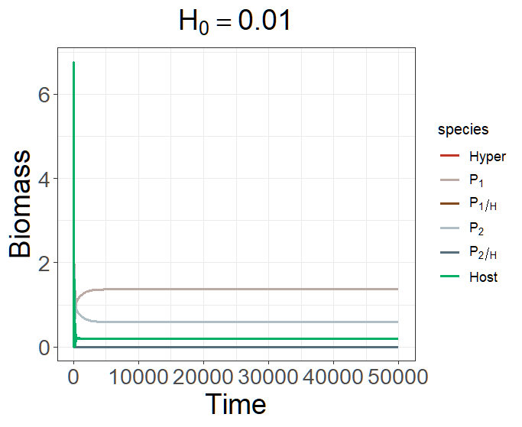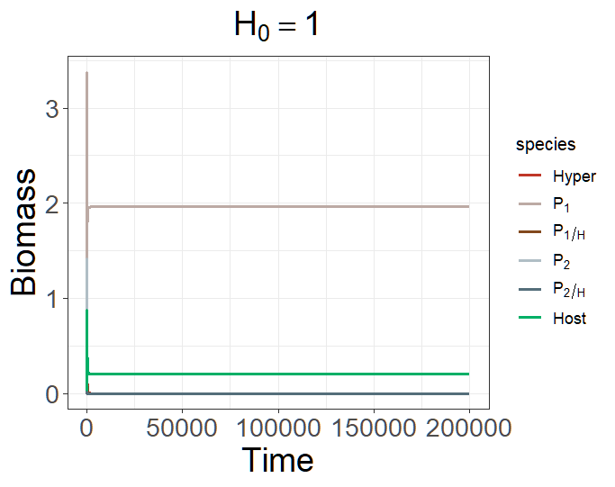
state <- c(H = 0.01/1, P1H = 0, P2H = 0, P1 = 0.01, P2 = 0.01, S = 0.2)
parms <- c(r = 1, K = 10,
+ a1 = 0.5, a2 = 0.5, R1 = 1, R2 = 1, e1 = 0.5, e2 = 0.5,
+ b1 = 0.3, b2 = 0.45, m1 = 0.05, m2 = 0.05, e1H = 0.5, e2H = 0.5,
+ o1 = 0.8, o2 = 0.8, h1 = 1, h2 = 1, c1 = 0.9, c2 = 0.9, d = 0.03, DL = 0)

Alternative stable state
When H is large and α₁ = α₂, P₂ will be excluded because H is too large.

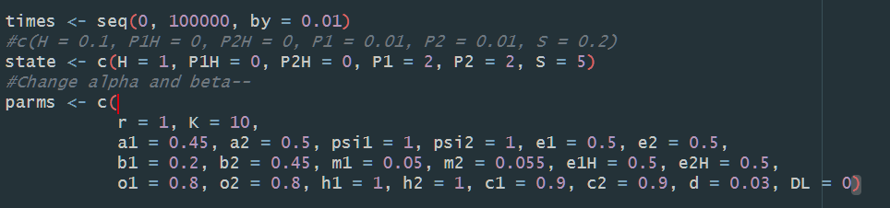

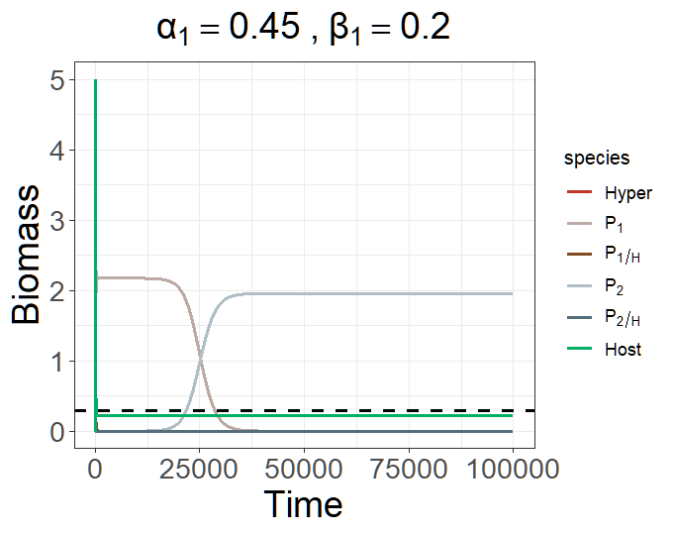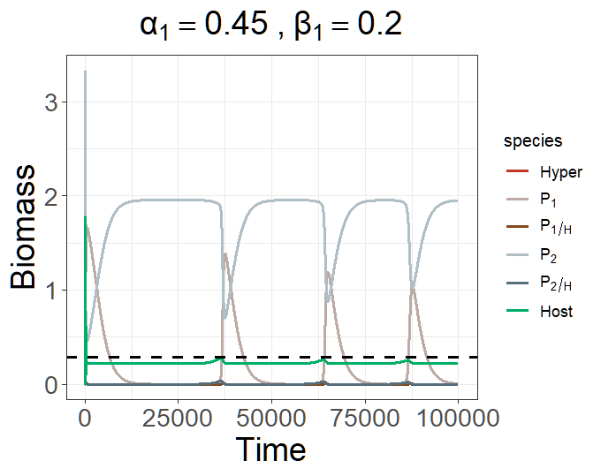
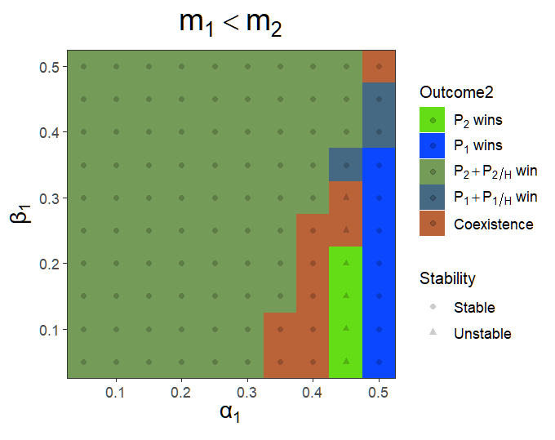
Because unstable

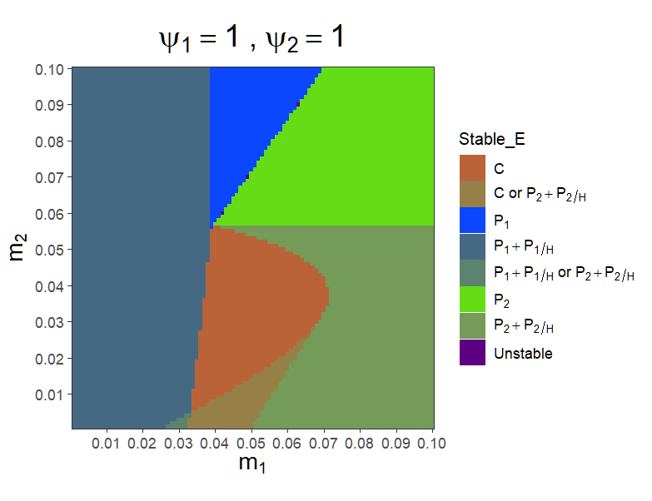
There are alternative stable states when both $m_{1}$ and $m_{2}$ are small.
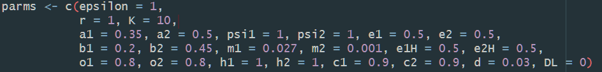


When $m_{1}=0.027,m_{2}=0.001$, there are two stable equilibrium points, which leads to $P_{1}+P_{1/H}$ win or $P_{2}+P_{2/H}$ win.

When $P_{1}+P_{1/H}$ win,
H = 0.7258128, P1H = 0.3909225, P1 = 2.2271095, S = 0.8368879.

Try to increase the abundance of $H$ to make $P_{2}+P_{2/H}$ win:
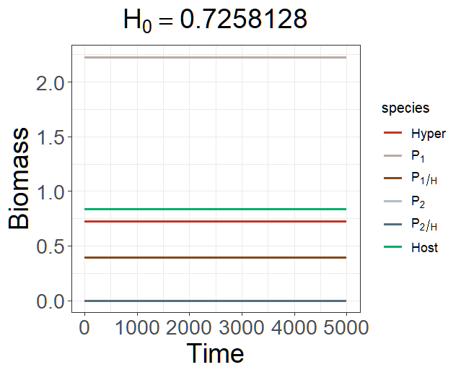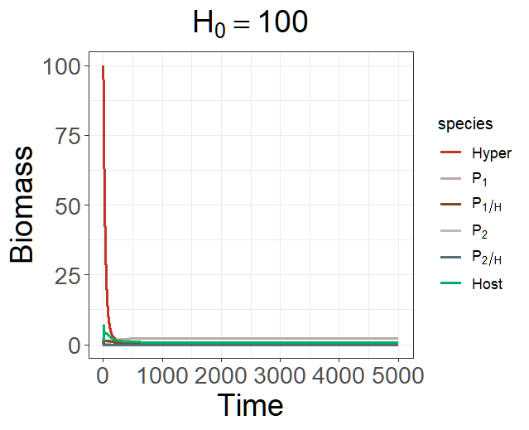

Simulation outcomes prove that $P_{1}+P_{1/H}$ win equilibrium (H = 0.7258128, P1H = 0.3909225, P1 = 2.2271095, S = 0.8368879) is stable. When increasing in initial abundance of $P_{2}$, the equilibrium will shift to the $P_{2}+P_{2/H}$ win equilibrium (H = 2.5047725, P2H = 0.9499769, P2 = 0.6750948, S = 1.8746412).

When $P_{2}+P_{2/H}$ win,
H = 2.5047725, P2H = 0.9499769, P2 = 0.6750948, S = 1.8746412.
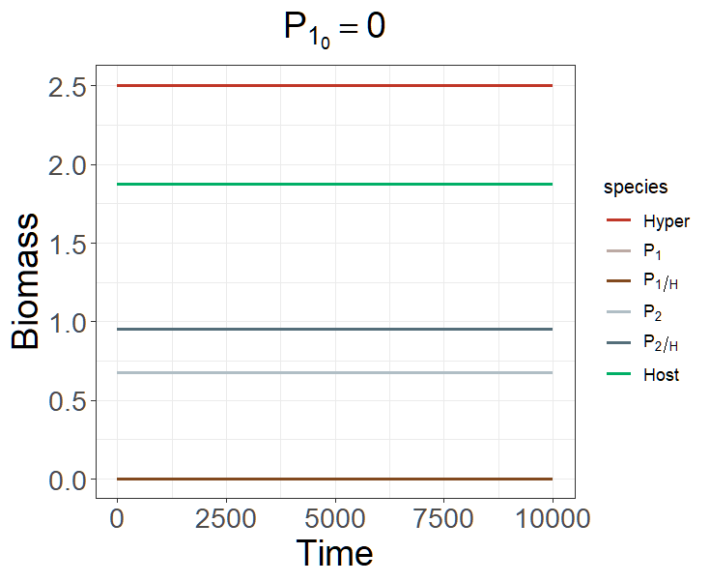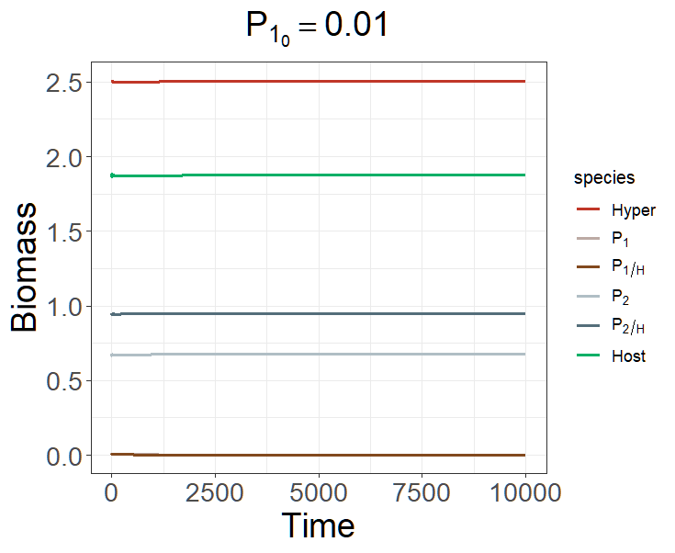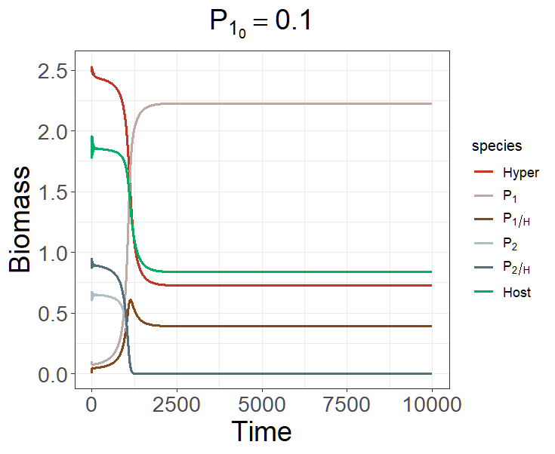
Simulation outcomes prove that $P_{2}+P_{2/H}$ win (H = 2.5047725, P2H = 0.9499769, P2 = 0.6750948, S = 1.8746412) is a stable equilibrium. When increasing in initial abundance of $P_{1}$, the equilibrium will shift to the $P_{1}+P_{1/H}$ win equilibrium (H = 0.7258128, P1H = 0.3909225, P1 = 2.2271095, S = 0.8368879)

有先後順序差別。
>> If $P_{1}$ enter the system after $P_{2}$, i.e., $P_{2}$ has reached its equilibrium, the system will easily replace by $P_{1}$.
If $P_{2}$ wants to invade after $P_{1}$ reach its equilibrium, then it will be hard to invade (nearly impossible).
可以算一下 invasion analysis 的條件。
Both $P_{2}+P_{2/H}$ and $P_{1}+P_{1/H}$ cannot invade each other. -> Priority effect.


When $m_{1}=0.05,m_{2}=0.01$, there are two stable equilibrium points, which leads to coexistence or $P_{2}+P_{2/H}$ win.
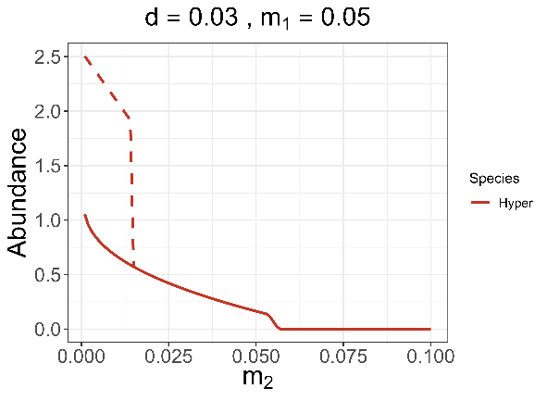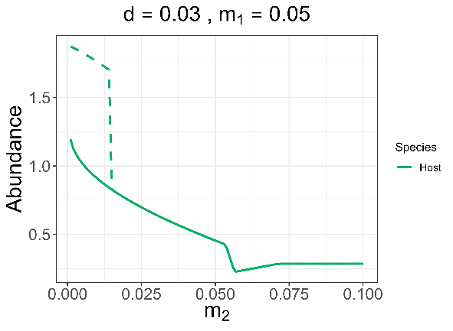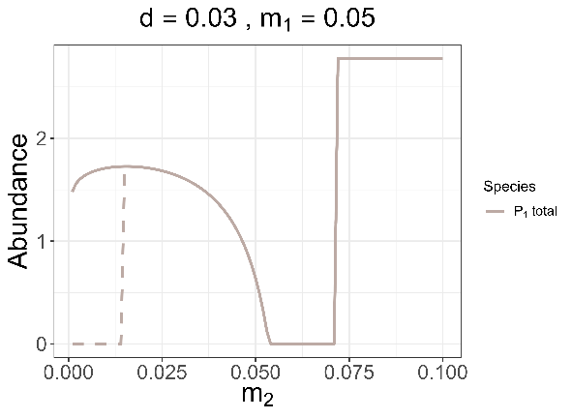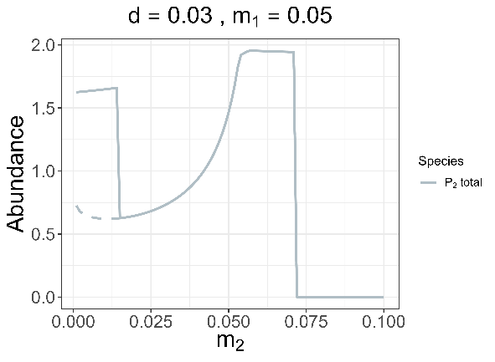

When both strains coexist,
H = 0.6716297, P1H = 0.2333761, P2H = 0.1687427, P1 = 1.4767783, P2 = 0.4522385, S = 0.9095539.
$$λ= -0.00259532$$
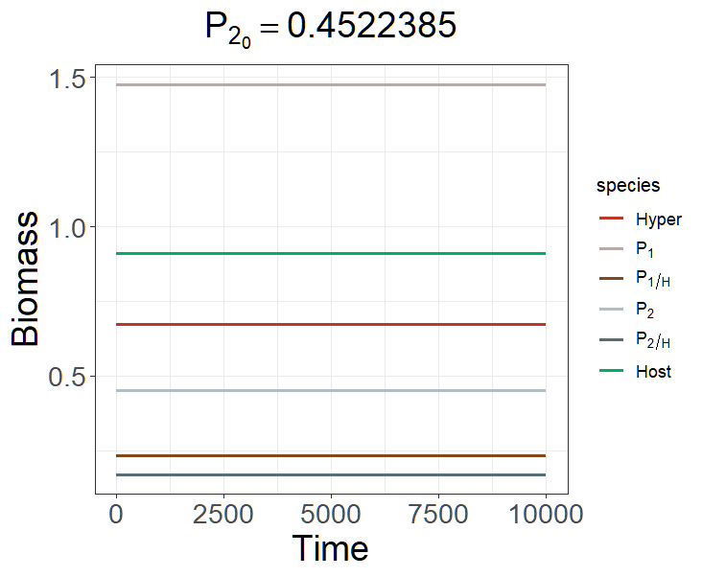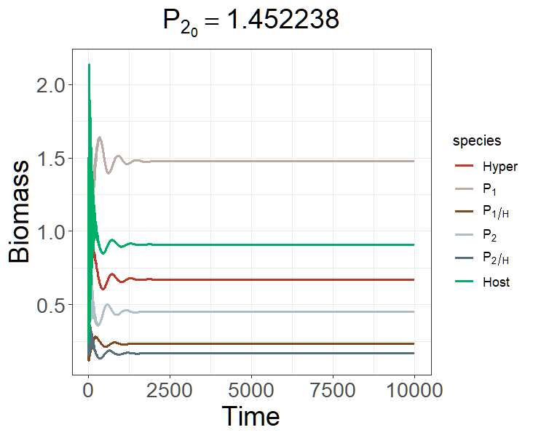
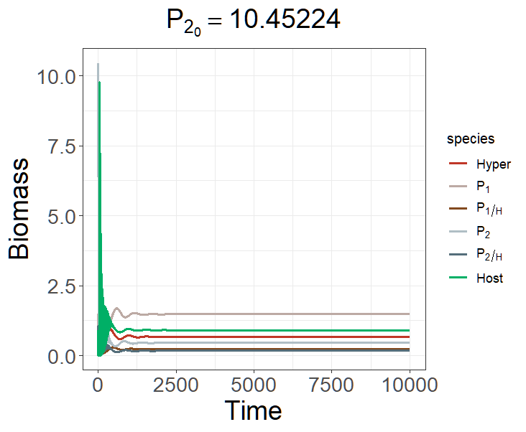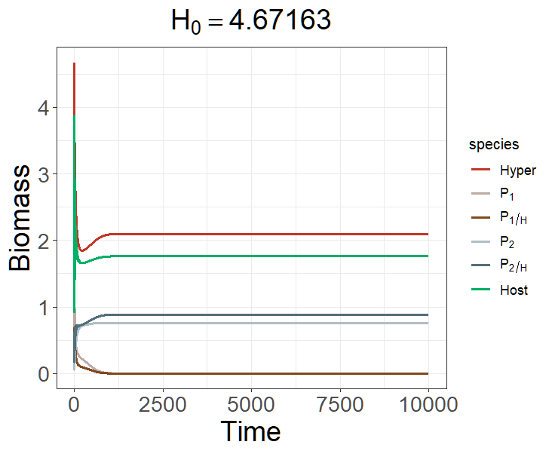
Why adding H can make virulent strain wins?
Because now $P_{1}$ has higher mortality rate, and there are many $H$ in the system, most of the $P_{1}$ will become $P_{1/H}$. The high mortality of $P_{1/H}$ and abundant H will make $P_{1/H}$ soon die of hyperparasite infection or die of natural mortality.
The reason why $E_{2H}$ would have more $H$ is that $P_{2}$ alone can contribute more $H$ in the system compared to the situation that two strains coexist.

When $P_{2}+P_{2/H}$ win,
H = 2.0989911, P2H = 0.8868977, P2 = 0.7605634, S = 1.7626948. $λ= -0.007603502$
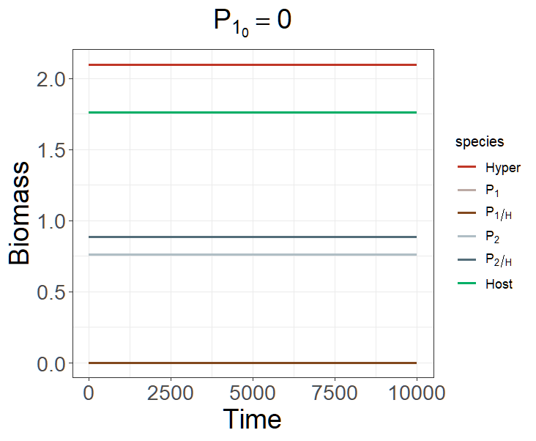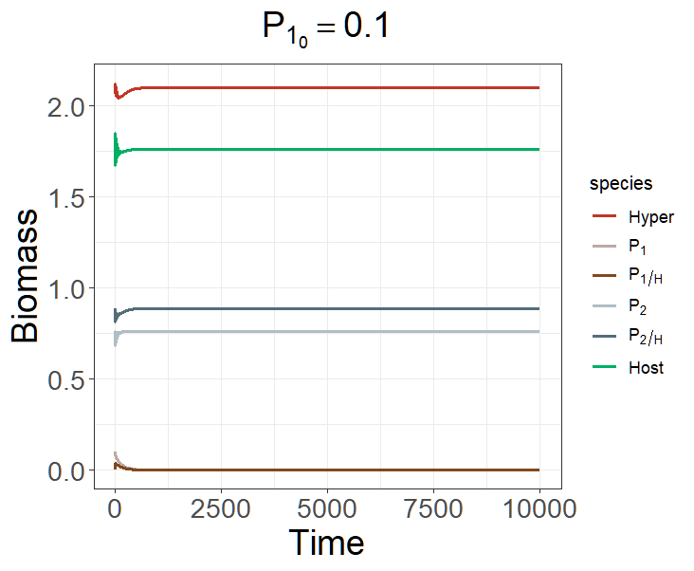
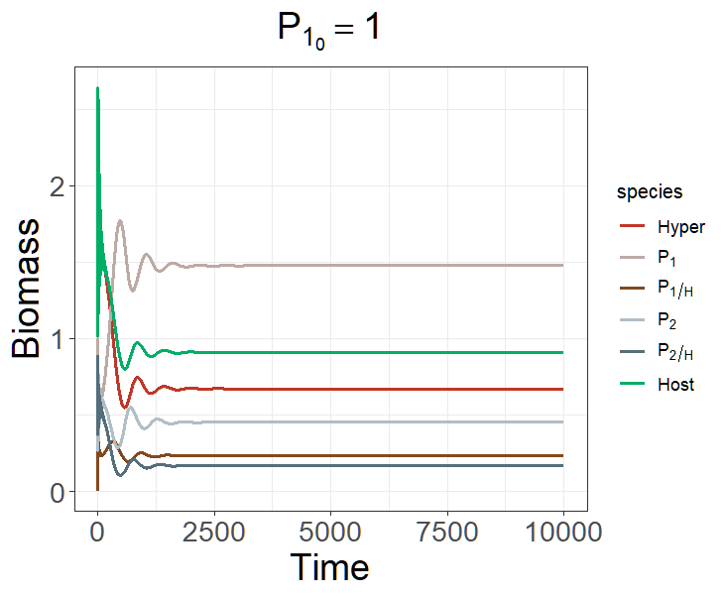

Invasion analysis show that $P_{1}+P_{1/H}$ cannot invade the $E_{2H}$ but $P_{2}+P_{2/H}$ can invade $E_{1H}$

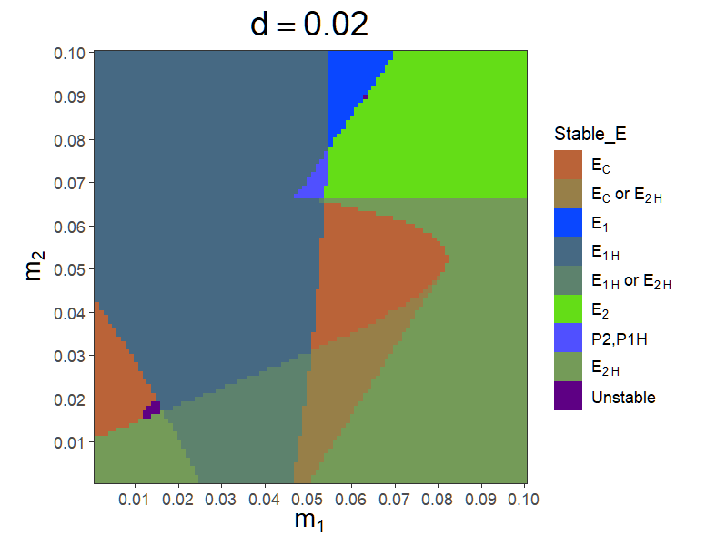
When $m_{1}=0.03,m_{2}=0.01$, there are two stable equilibrium points, which leads to $P_{1}+P_{1/H}$ win or $P_{2}+P_{2/H}$ win.

When $P_{1}+P_{1/H}$ win,
H = 2.1209743, P1H = 0.8003677, P2H = 0, P1 = 1.5660377, P2 = 0, S = 1.7175811.
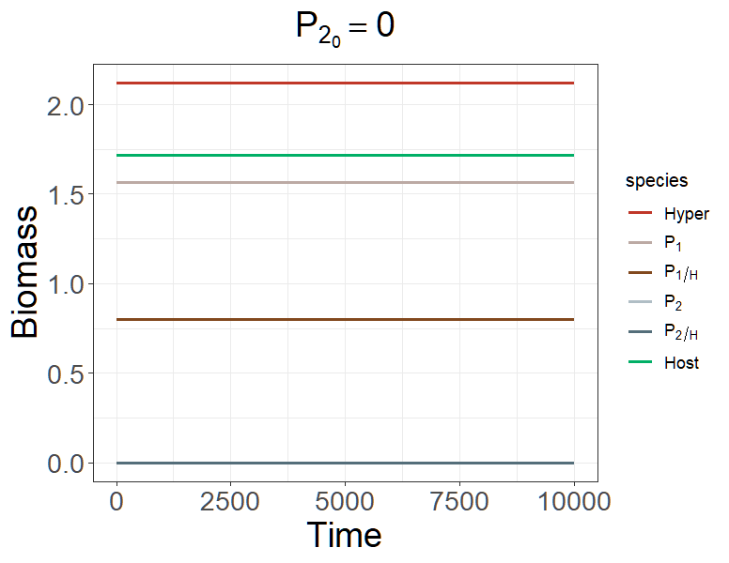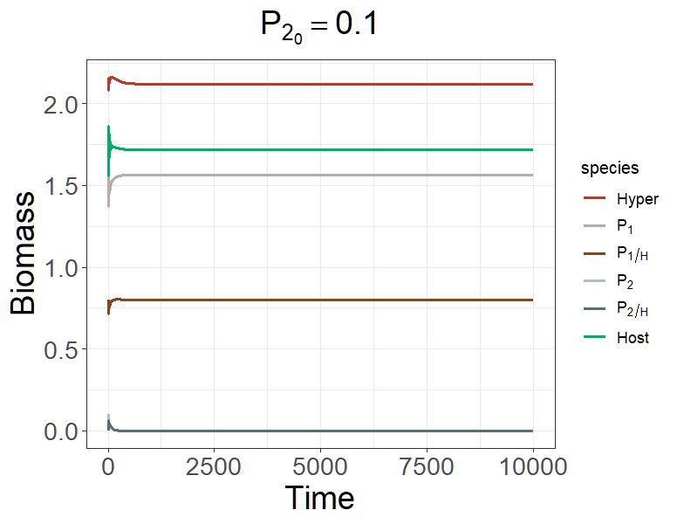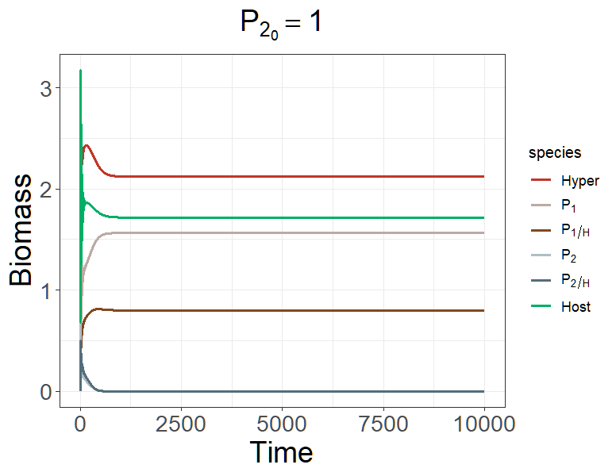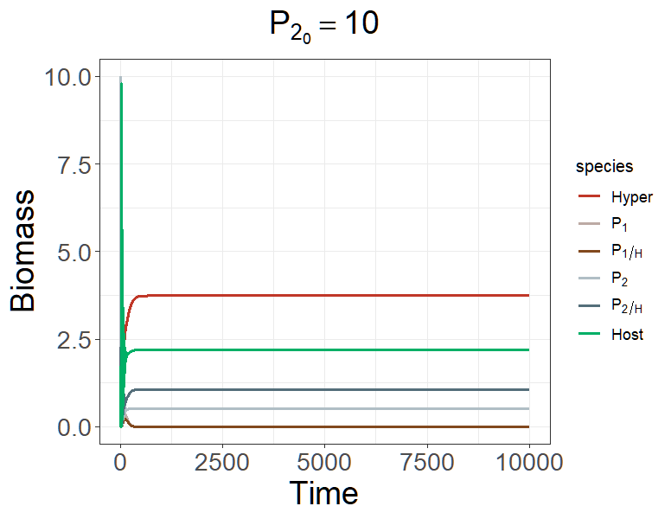


When $P_{2}+P_{2/H}$ win,
H = 3.7380543 , P1H = 0, P2H = 1.0529730, P1 = 0, P2 = 0.5070423, S = 2.1999235.
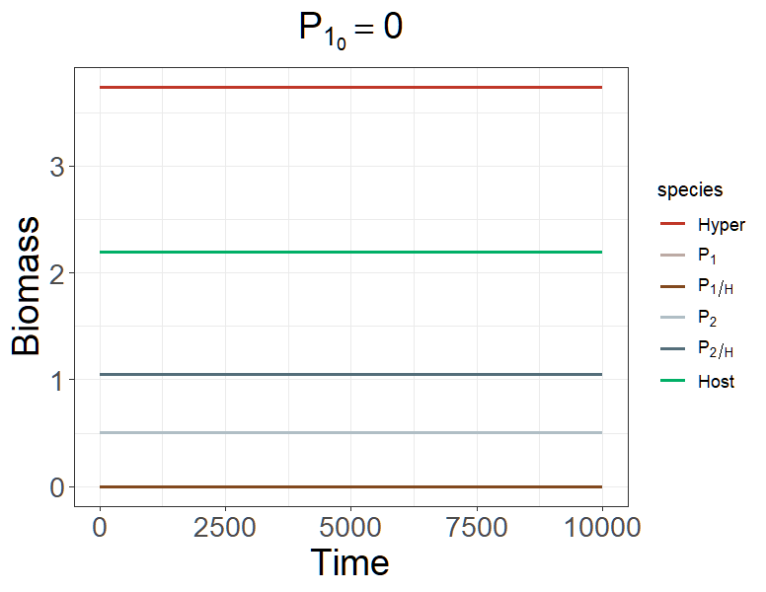

H = , P1H =, P2H = , P1 = , P2 = , S = .

